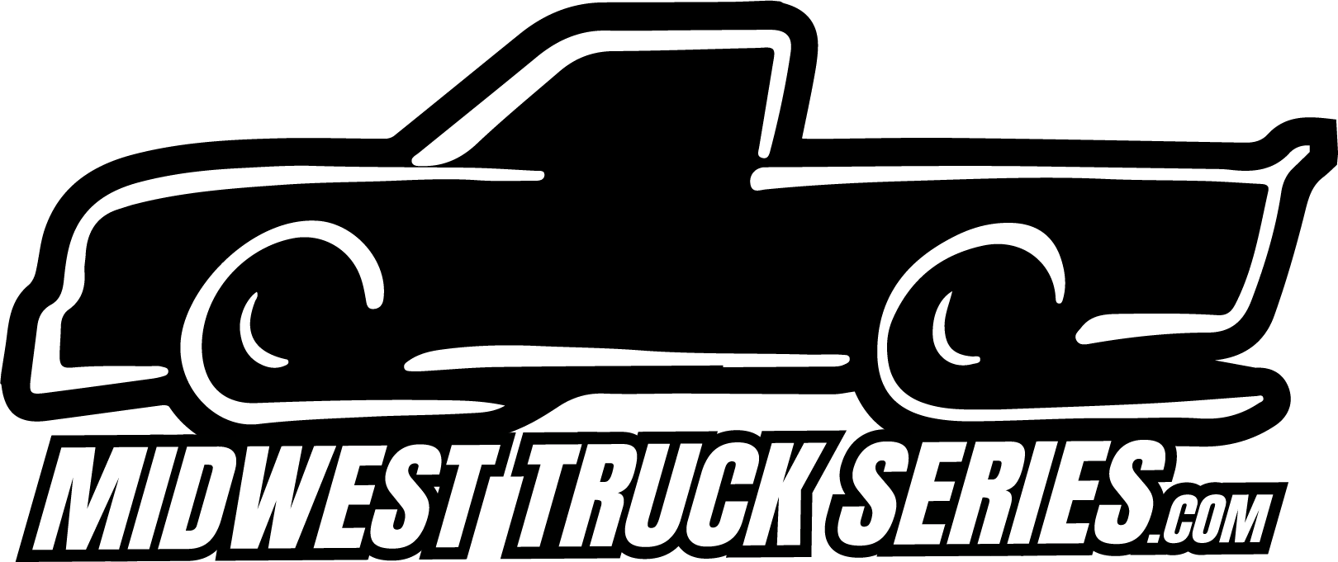

Midwest Truck Series 2024 Schedule

Saturday April 13 - Dells Raceway Park | Icebreaker 50
Sunday May 5 - Madison International Speedway | Joe Shear Classic 36
Saturday May 18 - State Park Speedway | Rib Mountain 50
Monday May 27 - Golden Sands Speedway | Memorial Day 50
Sunday June 16 - Milwaukee Mile | Father’s Day Special
Saturday June 22 - Marshfield Motor Speedway | Hub City 50
Sunday July 7 - Slinger Speedway | Prelude to the Nationals
Saturday July 13 - Grundy County Speedway | Land of Lincoln 50
Saturday July 20 - Jefferson Speedway | Truck Race at Jefferson
Tuesday August 6 - Wisconsin International Raceway | Dixieland Delight 35
Friday August 23 - Madison International Speedway | Howie Lettow Classic
Saturday August 31 - Dells Raceway Park | Jim Sauter Classic
Friday September 20 - Jefferson Speedway | WI State Championship
Saturday October 5 - La Crosse Fairgrounds Speedway | Oktoberfest

